


Multi-Functional Cane

ELBC803- Embedded Design Project
By

Ali Yazbeck – 94764
Serena Haidar – 90457
Zein Attar - 94266

Submitted to the Faculty of Engineering of the
Islamic University in Lebanon
Baalbek, Lebanon
In partial fulfillment of the requirements for the degree of

BACHELOR OF ENGINEERING IN COMPUTER AND COMMUNICATIONS
Spring 2024-2025

Approved by:
Dr. Mohammad Chreif

TABLE OF CONTENTS

CHAPTER 1 INTRODUCTION 1
1. What Is Engineering? 1
2. Project Idea and Objectives 1
3. What Is the Arduino Mega 2560? 2
CHAPTER 2 System Design and Implementation 3
2.1 Introduction 3
2.2 Required Components 3
2.3 Circuit Design 5
2.4 Implementation Steps 6
2.4.1 LDR Sensor 6
2.4.2 GPS+GSM modules 7
2.4.3 Ultrasonic Sensor and Audio Feedback 9
2.4.4 Water sensor with buzzer 11
2.5 Hardware 13
• Number and Type of Batteries Used 13
• Total Power Consumption Estimate 14
• Simulation Replacement with DC Power Block 14
2.5.2 Sensor and Module Integration 14
2.4.3 Automatic Lighting System 17
2.4.4. Emergency alert via email (GPS+ ESP32) 18
18
CHAPTER 3 Conclusion and Future Work 21
3.1 Conclusion 21
3.2 Future Work 21
CHAPTER 4 References 22

‘

LIST OF FIGURES

Figure ‎2.1 Full System Circuit Design 6
Figure ‎2.2 GSM and GPS module in Proteus 7
Figure ‎2.3:Ultrasonic sensor & buzzer wirings in Proteus 9
Figure ‎2.4 Water sensor and logic probe wiring in Proteus 11
Figure ‎2.5 Email send by ESP32 after pressing the emergency button 19

INTRODUCTION

What Is Engineering?
Engineering is the disciplined art of applying scientific and mathematical principles to design, build, and optimize structures, systems, and processes for humanity’s benefit [1]. Fundamentally, engineering solves real-world problems, serving people and the planet alike, and propelling society forward [2].
The field branches into specialties such as biomedical, chemical, electrical, civil, materials, and mechanical engineering, each addressing unique challenges from health to infrastructure to energy. Beyond these fields, emerging and interdisciplinary domains, like environmental, aerospace, software, and mechatronics, illustrate engineering’s boundless reach across modern life [3].
Yet all engineers share a common framework: define requirements, model solutions, test prototypes, and refine designs until form and function unite seamlessly.

Project Idea and Objectives
Globally, over 2.2 billion people live with a near or distance vision impairment or blindness. Alarmingly, at least 1 billion of these cases are treatable or preventable, highlighting a profound need for assistive technologies [4]
Vision loss often leads to reduced independence, limited mobility, and an increased risk of accidents, especially when navigating new environments.
Today, existing mobility aids like traditional white canes, often rely on mechanical contact feedback. More advanced versions offer vibration alerts or audio cues, yet neglect hazards like water puddles, low-light visibility, or emergency signaling. These limitations leave visually impaired people vulnerable in critical situations.
To bridge this gap, our project presents a Multifunctional Smart Cane: an integrated assistive system designed to extend the capabilities of traditional canes using embedded technology.
Key features:
- Ultrasonic sensors to detect nearby solid obstacles
- A water sensor to identify slippery surfaces like puddles
- A GPS + GSM module to allow users to send location-tagged SOS messages in emergency cases
- An LDR-based lighting system that activates a bright LED in dark environments to increase user visibility
- A digital compass and sound module intended to provide directional orientation cues
- A rechargeable Li-ion battery system, ensuring portable, long-lasting operation.

Project Objectives:
- Detect obstacles and slippery surfaces: Using ultrasonic sensors for solid objects and a water sensor for puddles.
- Enable Emergency response: One-button system sends GPS coordinates via SMS using GSM module.
- Improve visibility in low-light: Automatic LED activation triggered by an LDR sensor to make the user visible to others.
- Assist with basic directional navigation: A digital compass paired with sound feedback to help orient the user.
- Ensure long-lasting operation: Powered by a rechargeable Li-ion battery for portability and efficiency.
By delivering these features, we address the fundamental challenges of safety, independence, and confidence for visually impaired users.

What Is the Arduino Mega 2560?
Arduino Mega 2560 is a high-performance microcontroller board built around the ATmega2560 chip. It is designed for projects that require numerous inputs and outputs or complex control systems. With 54 digital I/O pins, 16 analog inputs, and 4 serial communication ports, it is well-suited for advanced embedded and automation projects, robotics, and large-scale sensor networks. [5]
Unlike boards with integrated wireless capabilities, such as the ESP32, the Mega 2560 relies on external modules (e.g., Bluetooth, GSM, or Wi-Fi) to extend its connectivity. It remains a popular choice for developers who prioritize pin availability and processing stability in large projects.
Arduino Mega 2560 Specifications [6]
- Microcontroller: ATmega2560
- Operating Voltage: 5V
- Input Voltage (recommended): 7–12V
- Input Voltage (limits): 6–20V
Memory
- Flash Memory: 256 KB (8 KB used by the bootloader)
- SRAM: 8 KB
- EEPROM: 4 KB
Digital and Analog I/O
- Digital I/O Pins: 54 (15 with PWM output capability)
- Analog Input Pins: 16
- PWM Channels: 15
- UARTs: 4 hardware serial ports
- Interfaces Supported: SPI, I2C, USB
Clocks and Timers
- Clock Speed: 16 MHz (external crystal oscillator)
- Timers: Includes hardware timers for PWM, timing, and interrupts

System Design and Implementation

Introduction
In this chapter, the components used in the Multi-Functional Smart Cane are presented, followed by a description of the systematic steps taken for its implementation.
The primary objective of this system is to enable visually impaired individuals to navigate their surroundings safely and independently by integrating sensors and modules for obstacle detection, location tracking, darkness detection, and emergency messaging.

Required Components
The following table lists all the components used to build the multi-functional smart cane. Each part was chosen based on its compatibility with the Arduino Mega 2560 and its relevance to the features we wanted to implement.

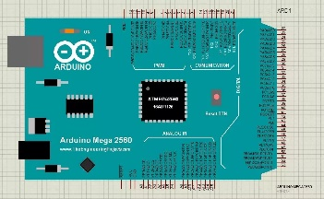 | ARDUINO MEGA-2560 x1  The brain of the system.
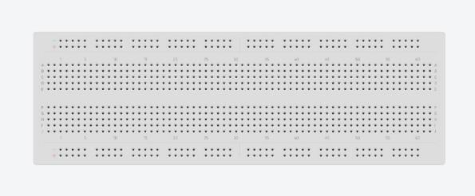 | Breadboard x1  For connecting components
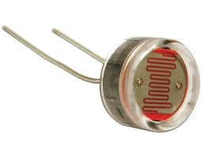 | LDR Sensor x1  Detects light intensity to automatically turn on a LED when it’s dark
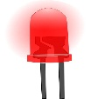 | LED x1  Lights up in dark areas based on the LDR readings
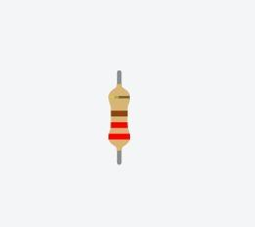 | Resistor 220-ohm x7  To implement electrical resistance as a circuit element
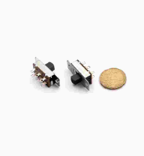 | Slide Switch, 6-pin ON_ON x1  To power the cane ON and OFF
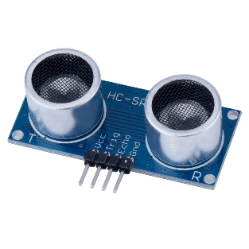 | Ultrasonic sensor 412 CH x3  To detect obstacles and send feedback to the DFPlayer
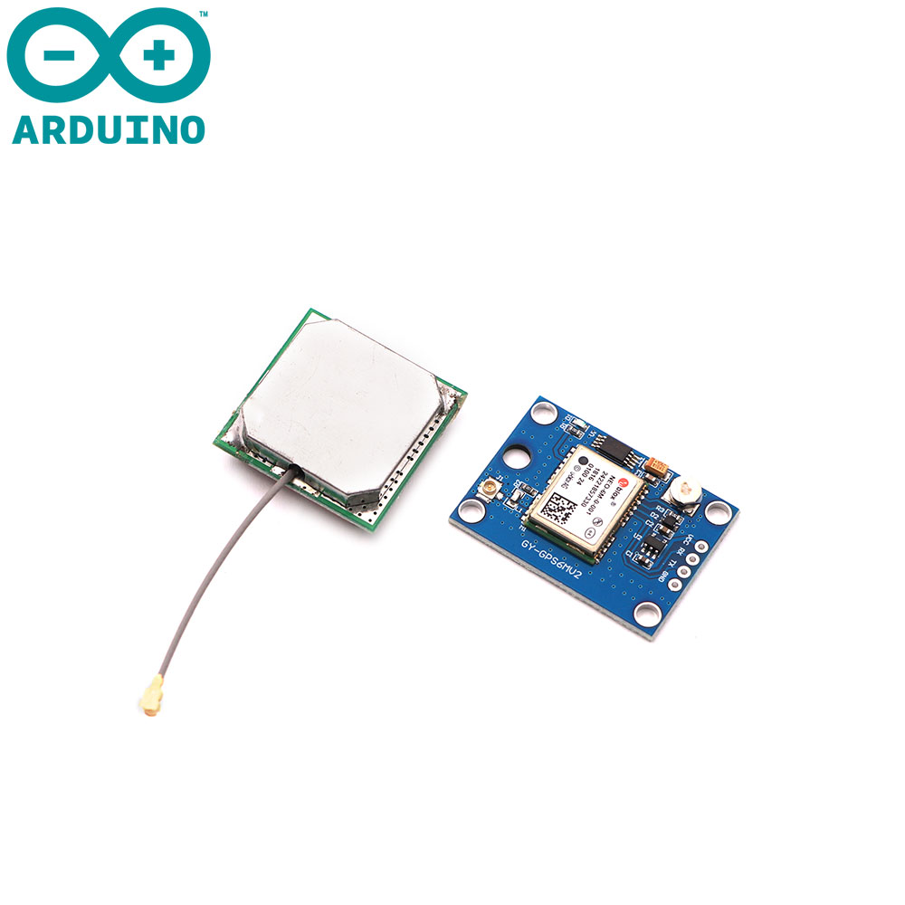 | GPS MODULE NEO-6MV2 x1  To acquire the location from satellites
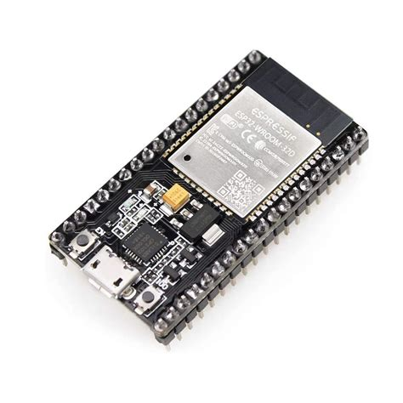 | ESP32 x1  To send an SMS when the emergency button is pressed
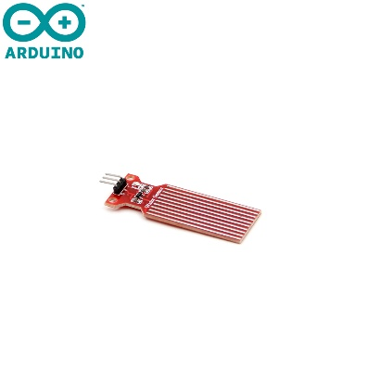 | HW-038 Water Sensor x1  To detect water puddles on the ground.
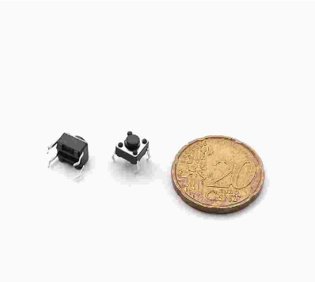 | Tactile switch 4-pin x1  Serves as an emergency button. When pressed, it activates the GSM module which sends the emergency SMS
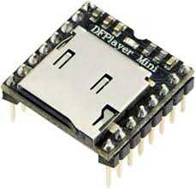 | DFPlayer-Mini module X1  Plays stored pre-recorded sounds for navigation from the SD Card
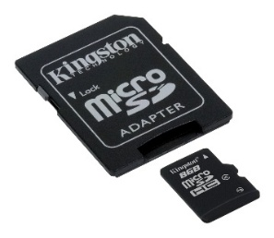 | Micro SD Card x1  To store the voice messages used for navigation feedback
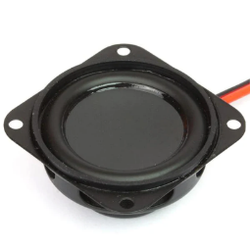 | Mini Speaker 4ohm, 3W x1  To play the sounds stored in the microSD card
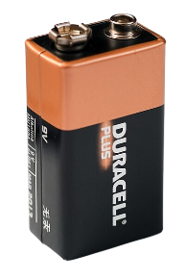 | DURACELL 6LP146 MN1604 x1  To provide power to the cane

Circuit Design
Figure 2.1 shows the full circuit schematic of the system, which includes the Arduino Mega 2560 microcontroller, ultrasonic sensors, a GPS and GSM modules for emergency functionality, and other components connected with proper power management, a common power source from the Arduino Vin pin, and common grounding. All components are connected to digital pins, except for the light sensor, connected to an analog pin.
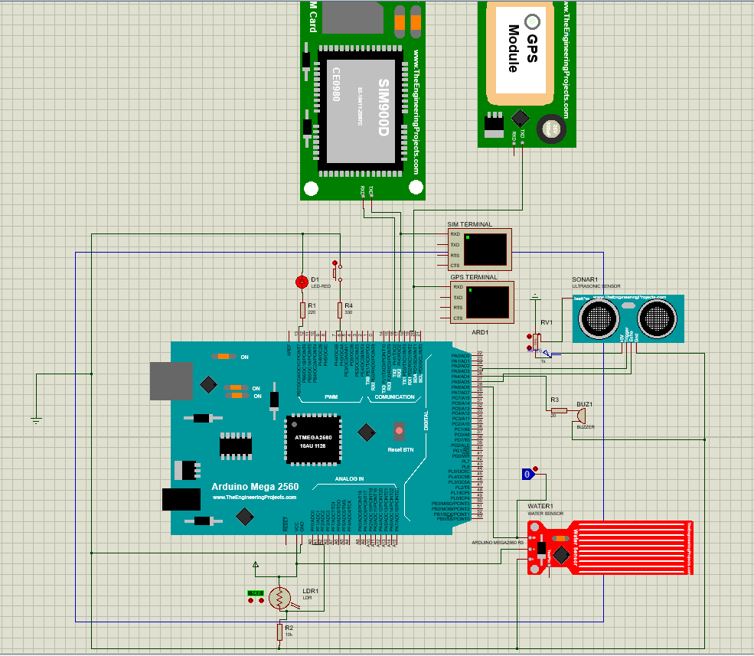
Figure ‎2.1 Full System Circuit Design

Implementation Steps

2.4.1 LDR Sensor
In this step, an LDR sensor is connected to the analog pin A0 and a LED to the digital pin A8 of the Arduino Mega 2560. When the LDR detects darkness (light level gets below a set threshold), the Arduino turns on the LED automatically. This feature helps the user to walk safely in low-light environments by turning on the light without any manual input and being seen by others.

Code:
int ldrPin = A0; // LDR connected to analog pin A0
int ledPin = 8; // LED connected to digital pin 8
int threshold = 500; // Light threshold for darkness
void setup() {
pinMode(ledPin, OUTPUT);
Serial.begin(9600);
}
void loop() {
int lightLevel = analogRead(ldrPin); // Read light value
if (lightLevel < threshold) {
digitalWrite(ledPin, HIGH); // Turn on LED
} else {
digitalWrite(ledPin, LOW); // Turn off LED
}}
Explanation
- analogRead(): reads the light level from the LDR.
- If the value is less than 500 (dark), the LED turns on.
- If it's brighter, the LED stays off.
This ensures safer navigation for the user in the dark, making them more visible to others.

2.4.2 GPS+GSM modules
To assist the visually impaired person in case of an emergency, such as a fall, an injury, or getting lost, an emergency button is implemented. When pressed, it sends the person’s location coordinates as an SMS message to a preset emergency contact.
The location is acquired from satellites using the GPS module, and the GSM SIM module send the message to a phone number.

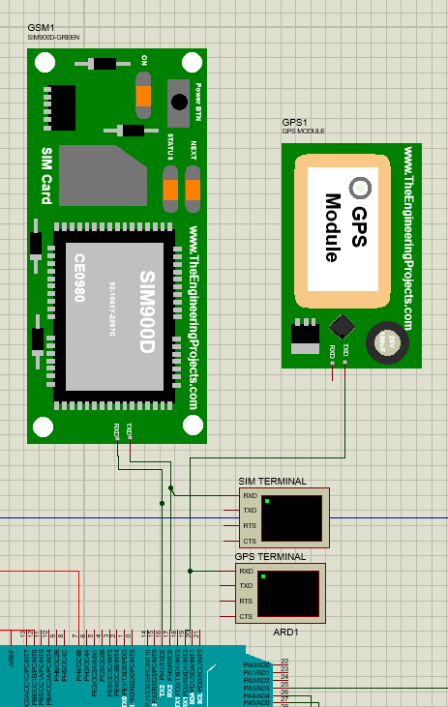
Figure ‎2.2 GSM and GPS module in Proteus

Wiring Overview:
The GPS and GSM modules both have 4 pins : TX, RX, VCC and GND.
- GSM module (SIM800L GSM module):
  - VCC → 5V power supply
  - GND → Ground
  - TX → Connected to pin RX2(pin 17) on Arduino Mega
  - RX → Connected to pin TX2 (pin 16) on Arduino Mega
- GPS module (NEO-6M V2):
  - VCC → 5V power supply
  - GND → Ground
  - TX → Connected to pin RX1on Arduino Mega
  - RX → Not connected, since the GPS only sends and doesn’t receive information.

Code:
void loop() {
// GPS
while (Serial1.available()) {
gps.encode(Serial1.read());
}

// Emergency Button
static bool smsSent = false;
if (digitalRead(buttonPin) == HIGH && !smsSent) {
sendEmergencySMS();
smsSent = true;
}
else if (digitalRead(buttonPin) == LOW){
smsSent = false;
} }

// functions used for GPS
void sendCommand(String cmd) {
Serial2.println(cmd);
delay(400);
}

void sendEmergencySMS() {
Serial2.println("Button pressed — attempting to send SMS");
Serial2.println("Valid GPS — sending SMS");
String msg = "EMERGENCY:\nLat: " + String(gps.location.lat(), 6) +
"\nLng: " + String(gps.location.lng(), 6);

Serial2.println("AT+CMGF=1");
delay(200);
Serial2.println("AT+CMGS=\"+96171555888\"");
delay(200);
Serial2.print(msg);
delay(200);
Serial2.write(26); // End SMS (CTRL+Z)
delay(2000);
}

Explanation:
- Serial1: receives GPS data via the NEO-6M module.
- gps.encode(): decodes incoming GPS data to extract coordinates.
- digitalRead(buttonPin): checks if the emergency button is pressed.
- If pressed, sendEmergencySMS() sends an SMS with the current location.
- Serial2: used to send AT commands to the GSM module (SIM800L).
- The SMS includes latitude and longitude for emergency assistance.

This allows real-time location sharing in emergencies, improving the user's safety and response time.

2.4.3 Ultrasonic Sensor and Audio Feedback

In order to detect obstacles and avoid them, the cane needs to be equipped with ultrasonic sensors and provide immediate audio feedback via a DFPlayer Module enabled with an SD Card of pre-recorded sounds.
The Arduino Mega reads input from the sensors, and when an obstacle is close, it activates the DFPlayer Mini, which outputs voice messages stored on an SD card, guiding the user left or right.
For simplicity in the simulation phase, a buzzer feedback is implemented, and the distance controlled by a potentiometer. This feedback mechanism operates continuously, ensuring that the user is warned of obstacles in real time

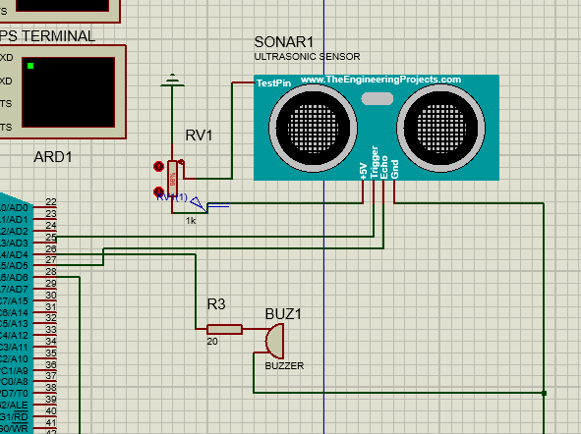
Figure ‎2.3:Ultrasonic sensor & buzzer wirings in Proteus

Wiring Overview:
The ultrasonic sensor has 5 main pins: Trigger, Echo, TestPin, VCC and GND.
- Ultrasonic sensor (HC-SR04):
  - VCC → 5V power supply
  - GND → Ground
  - Trigger → Connected to pin PA3 / AD3 (pin 25) on Arduino Mega
  - Echo → Connected to pin PA5 / AD5 (pin 27) on Arduino Mega
  - TestPin → Connected to the wiper of a potentiometer (RV1) to simulate distance changes

- Potentiometer (RV1):
  - One end to 5V
  - Other end to GND
  - Wiper (middle pin) → Connected to TestPin of the ultrasonic sensor, allowing the simulation of different distances by adjusting the potentiometer, mimicking how objects are positioned closer or farther.

- Buzzer:
  - Positive pin → Connected to pin PA4 / AD4 (pin 26) on Arduino Mega
  - Negative pin → Connected to GND

Code:
const int trigPin = 25; // Ultrasonic Trigger pin
const int echoPin = 27; // Ultrasonic Echo pin
const int buzzerPin = 26; // Buzzer control pin
void setup () {
pinMode (trigPin, OUTPUT);
pinMode (echoPin, INPUT);
pinMode (buzzerPin, OUTPUT);
Serial.begin(9600);
}
void loop () {
// Send ultrasonic pulse
digitalWrite (trigPin, LOW);
delayMicroseconds (2);
digitalWrite (trigPin, HIGH);
delayMicroseconds (10);
digitalWrite (trigPin, LOW);
// Read echo response time
long duration = pulseIn (echoPin, HIGH);

// Convert to distance (cm)
float distance = duration * 0.034 / 2;

// Activate buzzer if object is too close
if (distance > 0 && distance < 15) {
digitalWrite (buzzerPin, HIGH);
} else {
digitalWrite (buzzerPin, LOW);
}
delay (300); // Stabilize readings

Explanation:
The code continuously measures distance using the ultrasonic sensor, for real-time obstacle detection. It sends a short pulse, waits for the echo, and calculates the distance based on the time it takes to return.
- If the measured distance is less than 15 cm, it means that an object is near, which turns ON the buzzer to alert the user.
- If no nearby object is detected, the buzzer remains OFF.

2.4.4 Water sensor with buzzer
To avoid slipping on water puddles on the ground or wet surfaces, a water detection feature is implemented, with a water sensor and a buzzer. The water sensor has two exposed probes that form a conductivity circuit.
When they come into contact with water, the circuit closes and its digital output is HIGH. The Arduino reads this via digitalRead(waterPin) and sets the buzzer pin HIGH, sounding an alert. When the probes are dry, the output returns LOW, and the buzzer is turned off. This immediate audible feedback warns the user of wet or slippery surfaces ahead.
To simulate this, a logic probe is used to detect water, using the same HIGH/LOW pin logic, providing a simple yet effective feedback system.
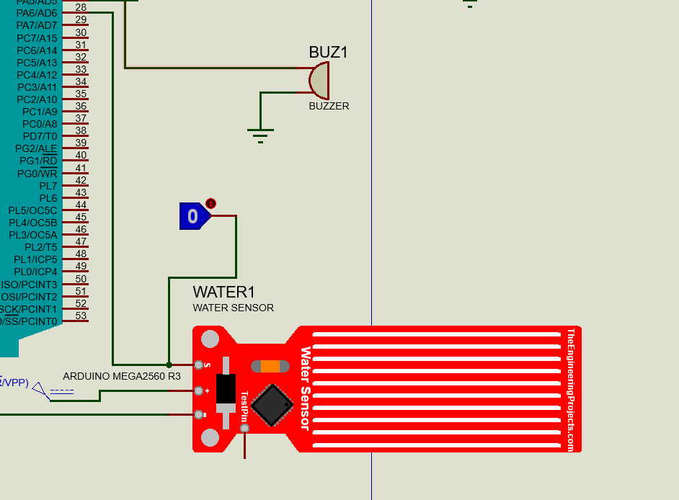
Figure ‎2.4 Water sensor and logic probe wiring in Proteus

Wiring overview:
- Water sensor module:
This module has one main pin connecting to the Arduino Mega to signal the presence of water.
  - VCC pin → Connected to 5V power supply
  - GND pin → Connected to Ground
  - S (Signal) pin → Connected to PA6 / AD6 (pin 28) on Arduino Mega

- Logic probe:
  - Connected to the signal pin S of the water sensor
  - Logic 1 (HIGH) → simulates the presence of water.
  - Logic 0 (LOW) → simulates dry conditions (no water detected).

Code:
const int waterSensorPin = 28; // PA6 / Analog pin 6
const int buzzerPin = 26; // Buzzer control pin // PA7 / Analog pin 7
void setup () {
pinMode (buzzerPin, OUTPUT);
pinMode (waterSensorPin, INPUT); // Read water sensor signal (S pin)
Serial.begin(9600);
}
void loop () {
int waterState = digitalRead(waterSensorPin);
if (waterState == HIGH) {// LOW means water is detected
Serial.println("Water Detected!");
digitalWrite (buzzerPin, HIGH); // Turn ON buzzer
} else {
Serial.println("No Water");
digitalWrite (buzzerPin, LOW); // Turn OFF buzzer
}
delay (300); // Wait }

The code checks for the presence of water using a water sensor. It reads the S pin of the sensor, which outputs a digital signal: HIGH if water is detected and LOW if the surface is dry.
If water is detected (signal is HIGH), the system:
- Prints a warning message: "Water Detected!"
- Activates the buzzer to alert the user.
This check happens repeatedly in the loop, so the system can immediately respond whenever water appears on the ground.

2.5 Hardware

INCLUDE IMAGE OF HARDWARE
In this section, we tackle the real-world assembly and integration of all hardware components into a fully functional prototype.
After simulating the system on Proteus 8, the multi-functional cane was physically assembled using sensors, modules, an Arduino Mega 2560 microcontroller, a breadboard, and jumper wires. All modules were tested individually then incorporated into the system. The goal was to create a fully operational assistive device for visually impaired individuals.

2.5.1 Power Management

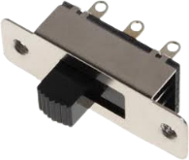

• Number and Type of Batteries Used
The system is powered using one non-rechargeable 9V alkaline battery (Duracell). This battery type is chosen for its simplicity, availability, and ability to provide sufficient voltage for the Arduino Mega.
• Voltage Regulation
No external voltage regulator (such as AMS1117 or a buck converter) is implemented. Instead, the Arduino Mega’s onboard voltage regulator manages the 9V input supplied via the VIN pin, converting it internally to a regulated 5V for system operation.
• ON/OFF Switch Placement and Function
A DPDT (Double Pole Double Throw) slide switch is used to control the system’s power state. Only one side of the switch (three pins) is utilized:
- The positive terminal of the 9V battery is connected to one of the outer pins of the switch.
- The middle pin is connected to the VIN pin on the Arduino Mega.
- The negative terminal of the battery is connected directly to the GND pin on the Arduino.
Toggling the switch enables or cuts the flow of current to the VIN pin, effectively powering the system ON or OFF.
• Charging Setup
No charging setup is required, as the 9V battery is a disposable, non-rechargeable unit. When depleted, the battery is manually replaced.

• Total Power Consumption Estimate
The Arduino Mega typically consumes around 70 to 80 mA during normal operation without external modules. With a standard 9V battery rated at approximately 500–600 mAh (milliampere‑hour) , the estimated runtime is 5 to 6 hours of continuous use.
• Battery Specifications
- Type: Alkaline 9V (Duracell)
- Nominal Voltage: 9.0 V
- Capacity: ~500–600 mAh (varies by brand)
- Rechargeable: No
- Connector: Standard snap clip connector
• Voltage Regulation (Internal)
- Regulator Type: Built-in linear regulator on Arduino Mega
- Input Voltage Range (VIN): 7–12 V
- Output Voltage: 5V regulated for system use
- Purpose: Steps down the 9V battery input to a safe operating voltage for internal circuits

• Simulation Replacement with DC Power Block
During development or extended testing, the 9V battery is disconnected and replaced with a 5V / 2A DC power adapter. The adapter is connected directly to the Arduino’s USB port or 5V header pin, ensuring uninterrupted operation and preventing battery drain during simulation.

2.5.2 Sensor and Module Integration
Obstacle Avoidance and Audio Guidance System
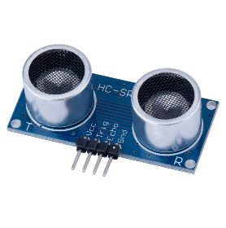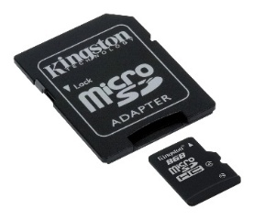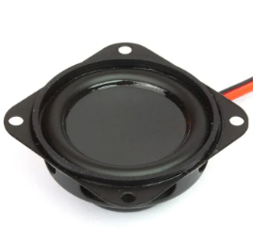
This part of the hardware is designed to help navigate safely by detecting obstacles using ultrasonic sensors and guiding the user through audio instructions.
The system uses three HC-SR04 ultrasonic sensors placed at the front, left, and right of the smart cane. These sensors continuously measure distances by sending ultrasonic pulses and calculating the time it takes for the echo to return. The distances are filtered to reduce noise and ensure stability in readings.
- If the front sensor detects an obstacle closer than the defined threshold, the system checks the left and right sensors.
- If the left side is blocked, the system instructs the user to "Go right" by playing a pre-recorded MP3 file using the MP3-TF-16P audio module connected to a mini speaker.
- If the right side is blocked, it instructs the user to "Go left".
- If both sides are blocked, a separate warning audio file is played to alert the user to “stop”.
- All audio messages are stored on a microSD card inserted into the MP3 module and are triggered by Arduino Mega through serial communication.
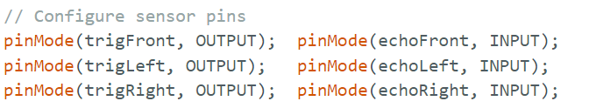

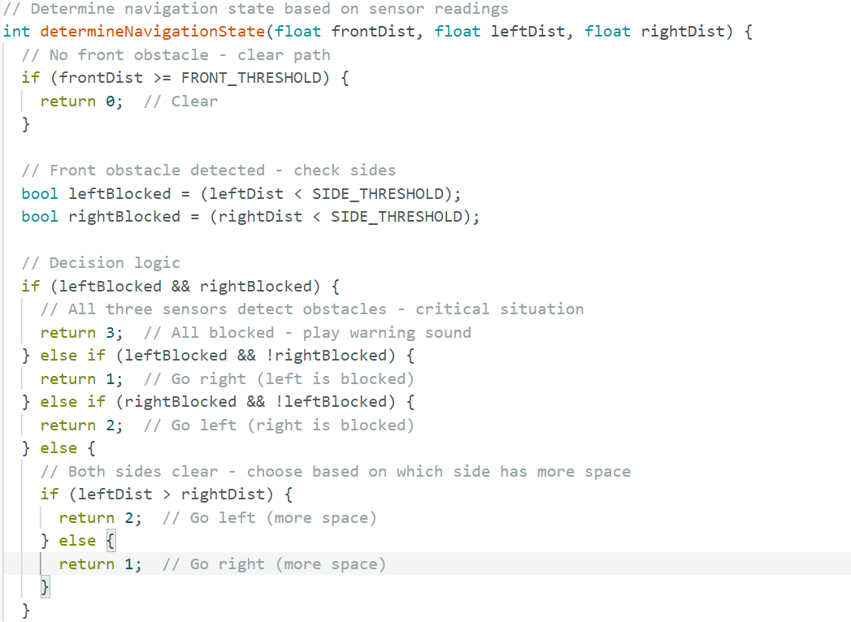
The DFPlayer Mini MP3 module plays a critical role in delivering audio-based navigation guidance to the user. It is a compact and low-cost audio playback module capable of reading MP3 files stored on a microSD card and outputting sound through a connected speaker.
How it works:
- The module reads audio files from a microSD card, with files named using numeric format (e.g., 001.mp3, 002.mp3).
- It communicates with the microcontroller (Arduino Mega in our case) using serial communication (TX and RX pins).
- When a specific command is sent (like play (1)), the DFPlayer plays the corresponding MP3 file.
- This allows dynamic, context-aware playback, like saying "Go left" when the right path is blocked.
- The DFPlayer Mini has built-in audio amplification, which allows it to directly drive a small speaker.
- A 3W 4Ω mini speaker is connected to the module’s speaker output pins (SPK_1 and SPK_2).
- This speaker converts the electrical audio signal into sound waves, delivering clear voice instructions to the user.

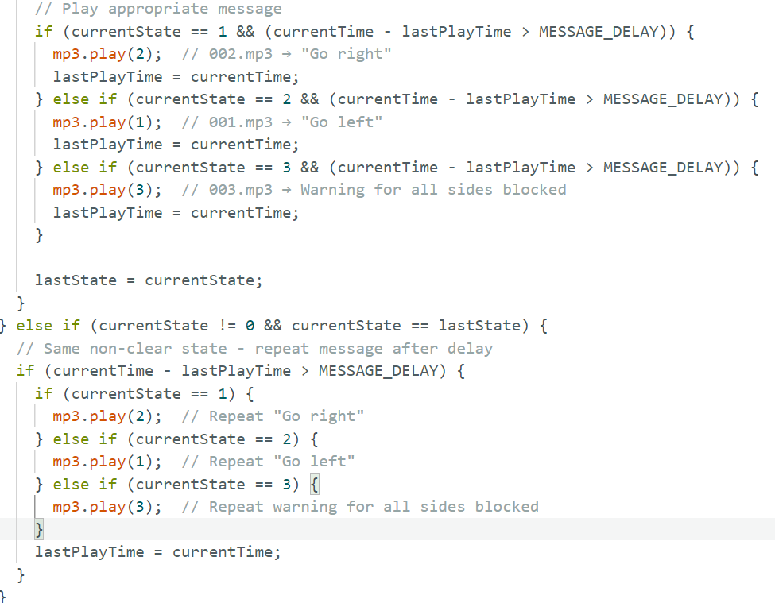

Automatic Lighting System

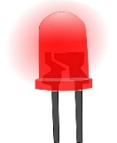


To improve safety in dark environments, the smart cane includes an automatic lighting system using an LDR (Light Dependent Resistor) and a red LED.
The LDR is a light-sensitive component whose resistance changes with light intensity:
- In bright light, the LDR’s resistance is low, and the voltage across it is also low.
- In darkness, its resistance increases, causing a higher voltage at the analog input pin.
This voltage is read by the analog pin (A0) on the Arduino Mega.

Logic:
- The code compares the LDR reading to a preset light threshold (e.g., 300 out of 1023).
- If the reading indicates darkness (value below the threshold), the system:
  - Turns ON the LED, improving the user's visibility.
- If the reading indicates enough light, the system:
  - Keeps the LED OFF to save power.

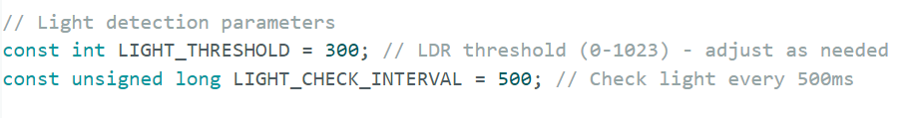
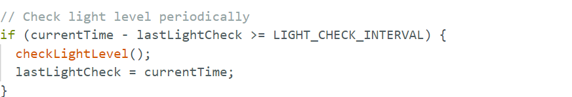

Emergency alert via email (GPS+ ESP32)

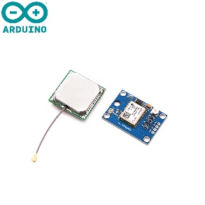

Due to weak GSM signal in our testing environment and repeated issues with the GSM module’s reliability, an alternative solution was adopted: sending emergency location emails using an ESP32 microcontroller with built-in Wi-Fi. This approach uses Wi-Fi from the user’s mobile phone via hotspot and allows the reliable delivery of emergency alerts without relying on cellular networks.
This circuit could not be simulated in Proteus, since every model of ESP32 for Proteus found online has the pins TX and RX inactive or blocked, so hardware was directly implemented.

How it works
- The ESP32 receives GPS data to track the user’s location continuously
- When the emergency button is pressed, the ESP32 extracts the most recent coordinates and sends them via email to a defined emergency contact

Suggestions:
- Add a code screenshot or briefly explain which service is used to send the email (e.g., SMTP with Gmail, IFTTT, or a webhook).

Wiring Overview
GPS Module(NEO-6M):
- TX → RX pin of ESP32
- RX → TX pin of ESP32
- VCC → VCC
- GND → GND

Push button:
- One leg → GND
- Other leg → GPIO D4 pin of ESP32

Code

Output

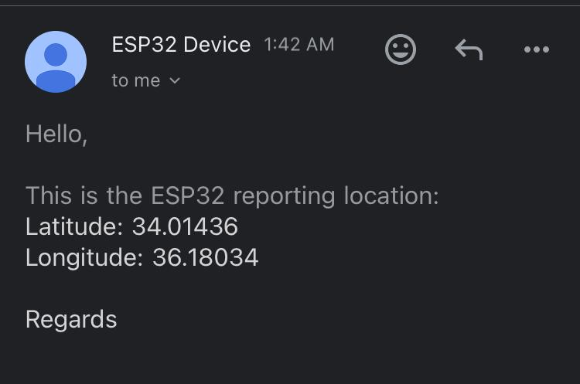
Figure ‎2.5 Email send by ESP32 after pressing the emergency button

🚨❗️🆘
https://emojis.wiki/emergency/

Subject: 🚨❗️🆘 EMERGENCY ALERT: Location of Visually Impaired User

Body:

This is an emergency alert from the smart cane system.

The user has pressed the emergency button. Their current location is:

Latitude: [LATITUDE]
Longitude: [LONGITUDE]

Please take immediate action.

- Smart Cane (ESP32)

2.5.1 Physical Assembly( (LATER WHEN WE ASSEMBLE IT)

All components were mounted onto or near the cane structure using adhesive supports, a small project box, and zip ties for stability. A solderless breadboard was used for temporary connections during development, while key sensors and modules were directly connected to the Arduino Mega 2560 using jumper wires. The Arduino board was securely housed near the top of the cane, allowing easy access to the USB port for power and code updates.

2.5.3 Testing Under real conditions
Purpose: Describe how you validated the prototype in real life.
Write about:
- Testing in a dark room (LDR)
- Obstacle detection with real walls/objects (ultrasonic)
- Placing water on the floor to test water sensor
- Outdoor GPS fix and receiving SMS on a phone
- Response time and buzzer loudness
📝 Mention who tested it (you, a peer, etc.), and any challenges faced like noise, delays, weak signals...
Brief mention of how you tested:
- LDR with slider
- Water sensor with logic probe
- GPS via injected NMEA sentences
- SMS monitored via virtual terminal

Example:
The fully assembled cane was tested in various real-world scenarios to evaluate its functionality:
- LDR/LED: The LED activated in dim lighting environments and turned off under normal room lighting, verifying LDR response accuracy.
- Obstacle Detection: The ultrasonic sensor reliably detected nearby walls and objects within 15 cm, activating the buzzer to alert the user.
- Water Detection: When placed near water, the sensor successfully triggered the buzzer alert, helping simulate wet surfaces or puddles.
- GPS and GSM: In open outdoor areas, the GPS acquired valid satellite data after a short delay. Pressing the emergency button sent an SMS with the current latitude and longitude to a predefined phone number.
- System Behavior: The system correctly handled multiple inputs, such as simultaneous darkness and obstacle detection, without errors.

Conclusion and Future Work

Conclusion
This project successfully implemented a multi-functional cane, designed to assist visually impaired people, utilizing embedded systems and sensor integration. By implementing features like obstacle detection, voice feedback, automatic lighting in darkness, and emergency email communication via GPS and GSM, the device tackles the various challenges faced by visually impaired people and helps them navigate their environment in a safer and more autonomous way.

The process of building the system involved research and experimentation in both simulation and hardware components. We faced and overcame many challenges, including software and hardware compatibility issues, and GPS module configuration in regions with limited network coverage. However, despite these obstacles, the prototype fulfills its functions and demonstrates the potential of embedded systems in the field of assistive technology.

Future Work
While this project proposes robust solutions to problems that blind and visually impaired people face daily, future work can be done to expand and enhance the system:
- Fall detection: Pairing the system with data from a smart watch to detect sudden falls or irregular movement patterns.
- Health monitoring: Adding a wearable device made of sensors that monitors heart rate, blood pressure, and other metrics.
- Real-Time GPS Tracking: Connecting the GPS module to a web interface using the Google Maps API, allowing family or caregivers to visualize the cane’s location in real time.
- Improved power management: Implementing a rechargeable lithium-ion battery system with power regulation to increase device runtime
- Object recognition with camera and AI: For users who lost their vision later in life, a camera can be integrated with a machine learning model to describe surroundings or identify locations (like store names or street signs), enhancing the user’s orientation and independence.

These improvements can evolve the multi-functional cane into a more intelligent, connected and personalized assistive tool, further supporting the mission of increasing the autonomy and safety of visually impaired people.

References

[1] | R. J. Smith, "Britannica," 28 Apr 2025. [Online]. Available: https://www.britannica.com/technology/engineering. [Accessed 8 May 2025].
[2] | A. C. o. E. Companies, "ACEC," Yoko Co, 2025. [Online]. Available: https://www.acec.org/about-acec/what-is-engineering/. [Accessed 13 May 2025].
[3] | N. University, "National University," 2025. [Online]. Available: https://www.nu.edu/blog/types-of-engineering/#15-different-types-of-engineering-jobs. [Accessed 13 May 2025].
[4] | W. H. Organization, "World report on vision," World Health Organization, 2019.
[5] | "Arduino Store," [Online]. Available: https://store.arduino.cc/products/arduino-mega-2560-rev3. [Accessed May 2025].
[6] | "Arduino Docs," [Online]. Available: https://docs.arduino.cc/hardware/mega-2560/. [Accessed May 2025].

